LZRA feedback
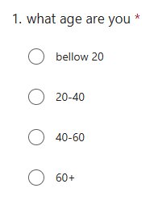

ask for users age to see how each age group uses the system and if it affects how they are using it, it allow us to asses a wide range of people and see who is strugging and why is it because of tech knowlage and how can we impove for them? ive done this using selection boxes as they have to pick one and they will be in one of the age brackets and this will help with acurate selecteion and no incorrct inputs

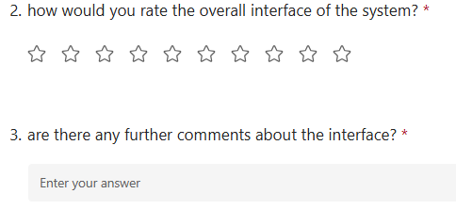

I have asked for a rating of how good they think the user interface is, this allows for a quick overveiw of what people think about the interface and can be presented and interpred quick and easy, then users can provide futher information about why they rated it that and what could be impoved on and what they like which can be kept and used to influnce the system.

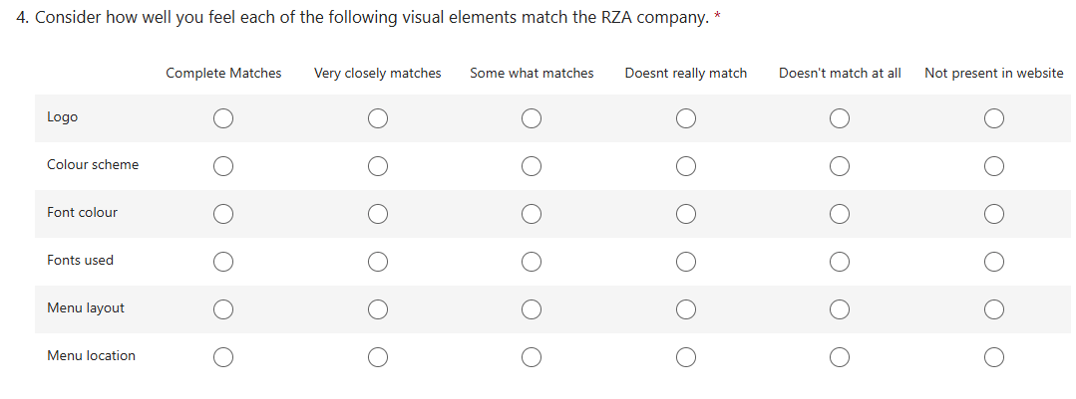

This question is a table and shows users different options for how well they thought it fit the brand, and allows them to scale it. This allows us to find what users think about specific parts of the system and why. This can let the user give more speific feedback withoiut making them have to think and consider the different parts themselves and its all laybled making for spific and helpful feedback with a veried scale.

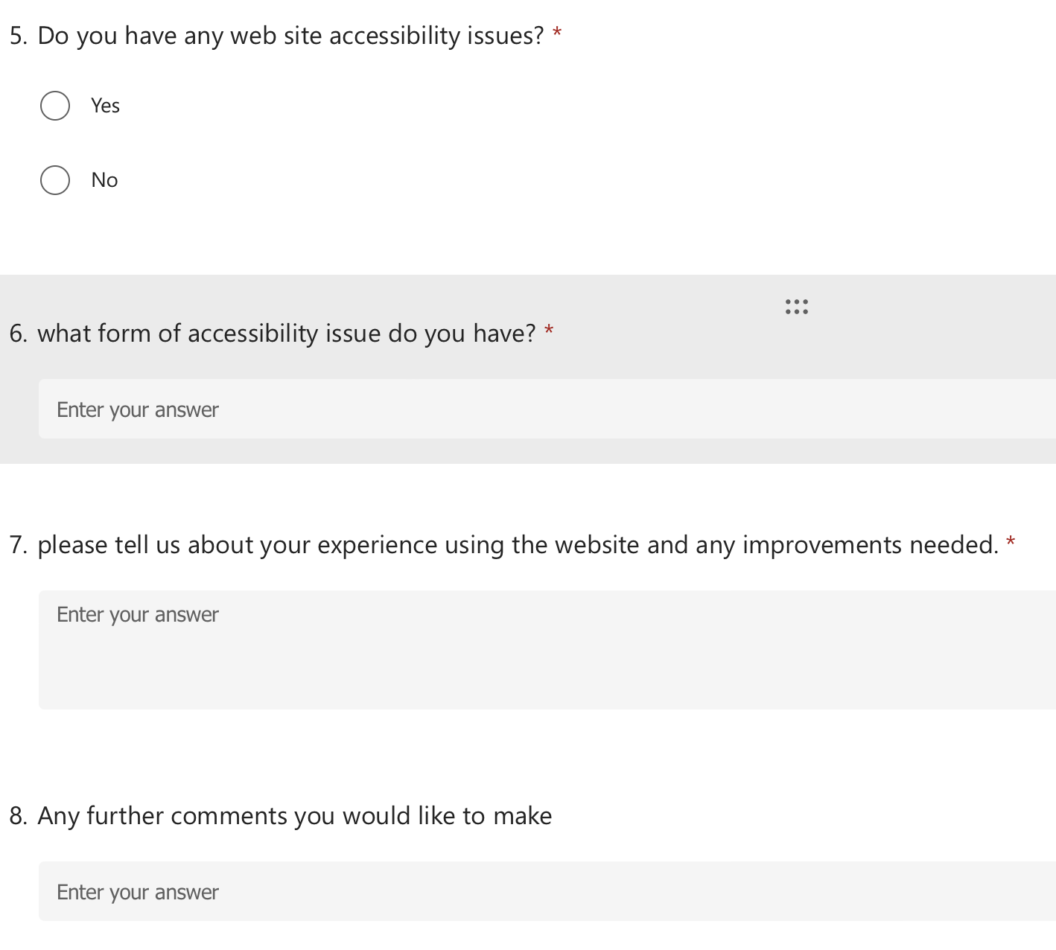

The first question here asks users if they have any accessibleity issues, if they do it then leads onto these further questions to ask for feedback from them about how easy it was to use for them and there disableity. If a users has no issues then it will pass the rest of these questions as they will not be able to answer as they wont be able to comment on it. If a user dose we ask what accessiblity issue they have, this means we can see how easy it is for people with different issues to use the system and if ther are any issues not thought about or require more accesibity feature.

Next once we know the disableity we can move onto asking about how there experince was, we can see if we made the site accessible enough to each user and if they had any trouble with it or a good experince so we know who we have accomidated for and any impovements needed can also be mentiond, once this is done we also see if there are further commonets they may want to add this just lets them express anything not questioned or not prevously stated to make sure we really hear about there needed and what they want on the system and how they have found it, this gives great feedback on how we can make it more accessible and what features are good and would be kept. This will give everyone a better chance to use the system and better customer experince, meaning more people will be able to book and attened the zoo and have a better experince doing so.

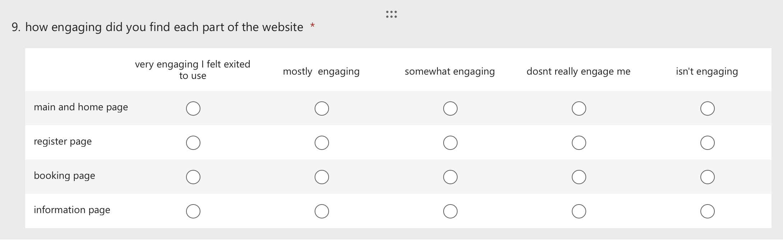

For a website its important to engaging the users esspecity when selling an experince, its important that we find out how enaged users are into the different parts of the website and if they felt engaing and exited the user about the experince. This is a mulitiple choice question that lets us know how enaging based of a scale to make sure its an acurate answer they felt on the difrent pages listed, it means the user dosnt have to think about putting in the text box what pages they want or forgetting or goving a basic answer, it provides a good structer for there response and allows for the most acurate feedback on the pages that are important to the system to make sure users feel engaged.

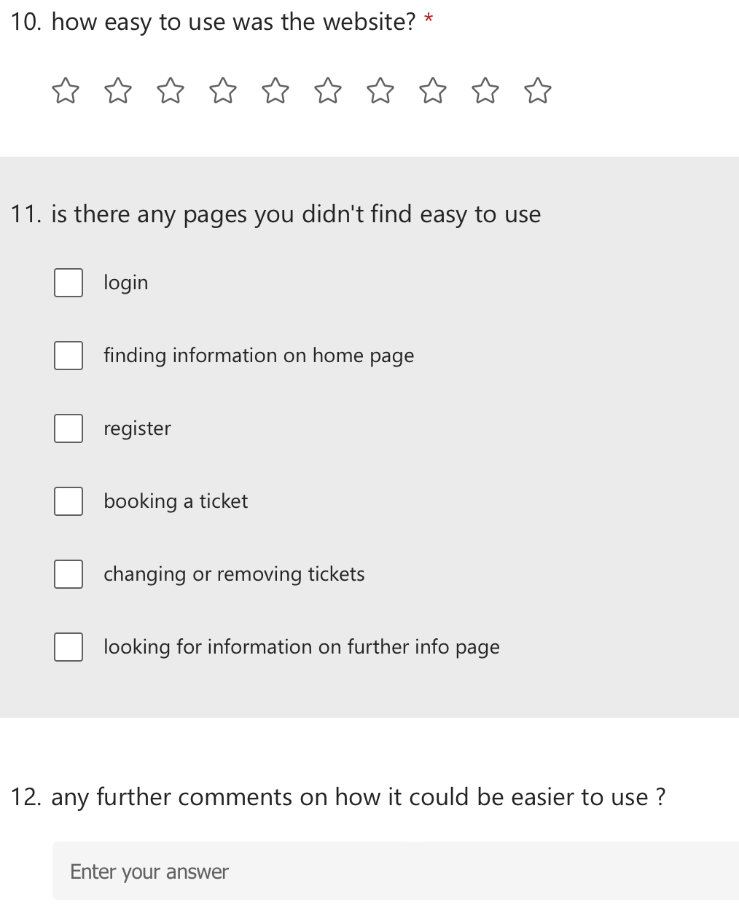

Here we have a few questions about how easy the system is to use, its impostant that for all age rages, knowlage and ablityits that everyone can use the website otherwise the system is not designed well and propperly to let everyone go to the zoo, this would limit who can go because some users may not be able to book tickets. The first question is a rating this is good and it will give us a genral overveiw of how easy the users felt it was to use, it allows a quick overall assessment and accurately as its ten stars not 5 of what they would rate the easy of use then you can look overall and see what overall users think and then find out if the system needs chnaging. Users can then chose boxes if they thought there where any pages they didt think where eays to use, then looking at an overveiw of this you can see in more depth where the issue is if there is a page that is difficalut and making customers not want to book and forceses users to think about each page speificly. Afterwards to find out why they thought this or give any tips on how it could be made easier users can write text in the box below which will allow users to say why and give resons and edits that can be made it it can or needs to be made better.

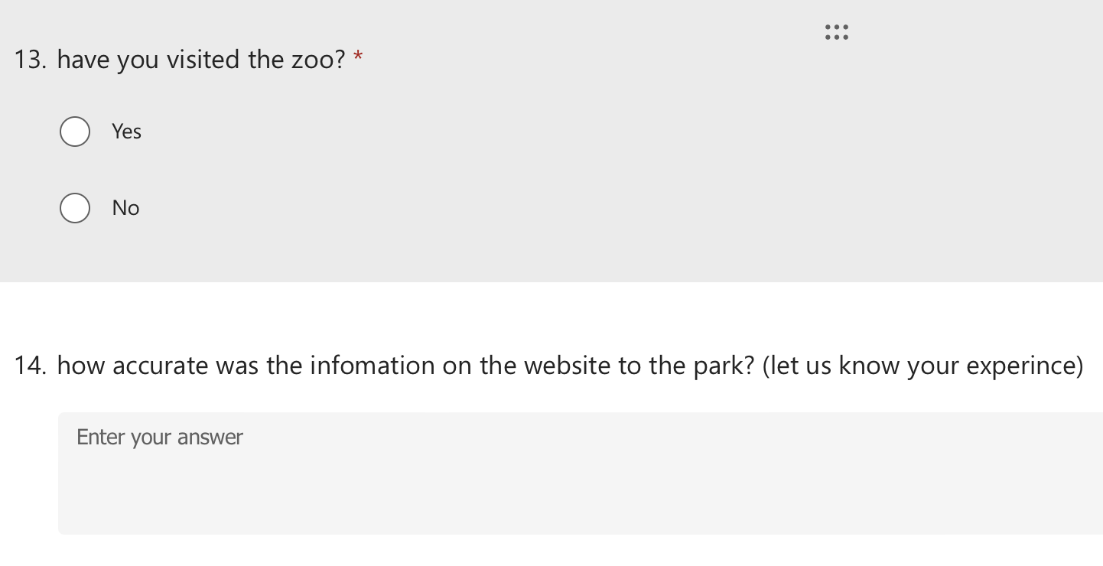

Here we are asking the user if they have already gone to the zoo and seen the zoo, if they have the user can then go onto a question that asks if the information about the park on the website was acurate to the acutal park and experince, if any information they then wanted avalible to them or thought was correct when they did see the park like item on menu changing then this can be edited on the website to more accurately reflect the park, this can be very important for some carers and any schools that must know details accurately esspeiliy if a kid or member of the group has serten needs so to make sure information is as accurate as possible its good to ask and reflect on information regulary.

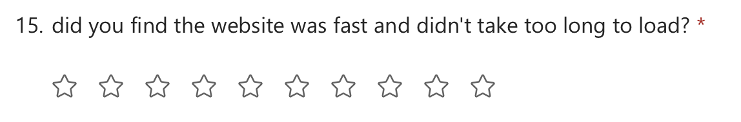

This question is asked as a rating to make sur ethe website is able to load and handle users esperly at busy times, it means we know if we need to find a way to hold a better load of people and impove its performace. This can be a disider if a user stays or looks on a website or not, it it wont load users wont stay on it.

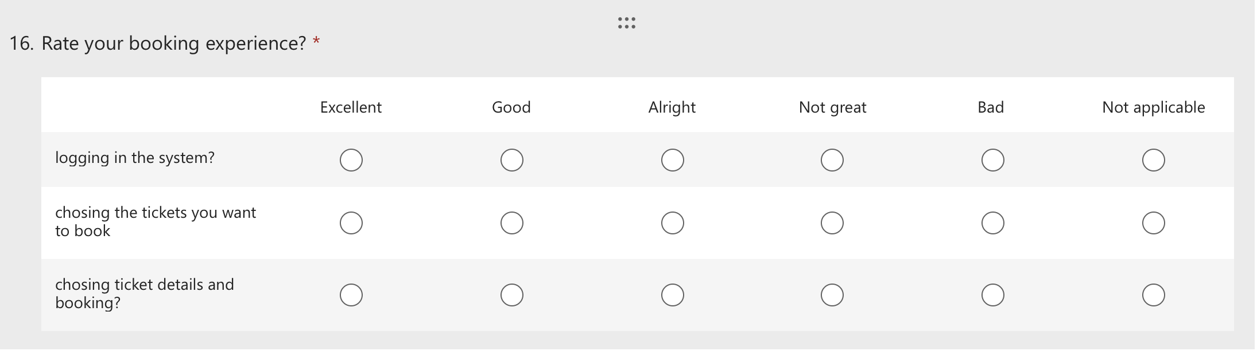
This is another scale allowing users to scale how good there experince was on different parts of the sytem, this gives a better idea of what parts of the system needs impovement and what parts are working well an dneed little change. This helps give users a better experince and be able to speificaly rate the different areas they might not think of.

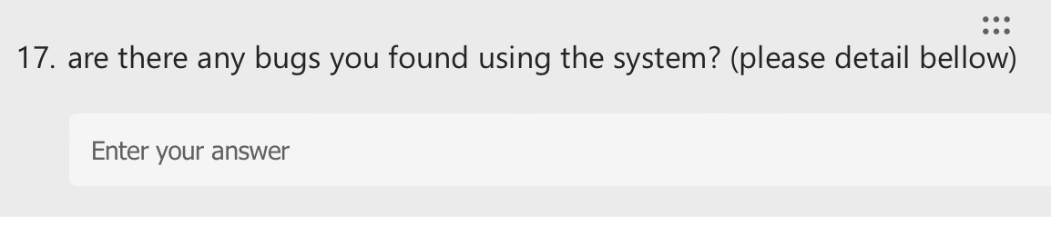
If users found any bugs while using the system these need to be recorded, its important there are logged to be taken care off, because bugs could lead to secuiriy issues, so to prevent this its really impostant to collect feedback to know so these can be looked at and fixed for better experince and more secuirty.

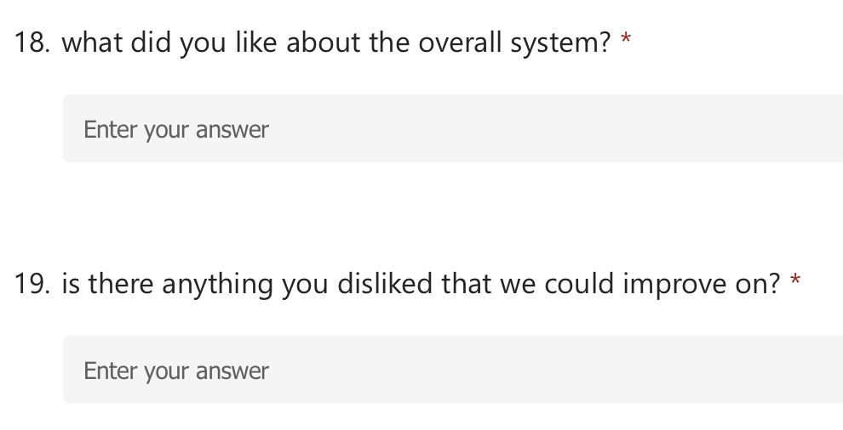

This follows from the question earlier on about the overall experince, this gives users the chance to spificaly state there experinces and likes and dislikes they fouced on and may want impovement on or really liked and should stay in the system. It can give a better idea around the users and there thoughts and just help give genral overall feedback and give there opinion of details they think needs to be commented on.

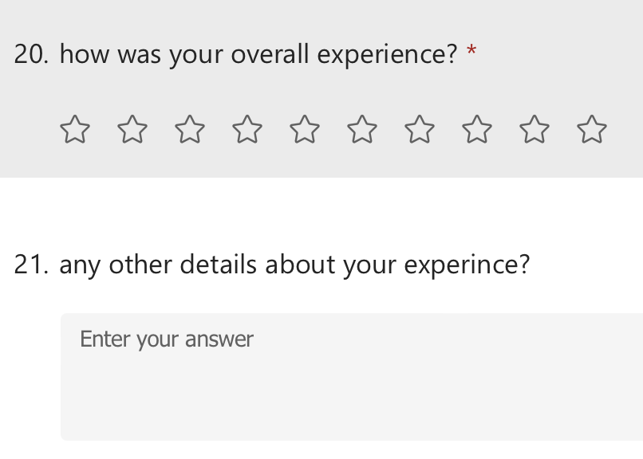

To finnsh off we have a rating, like before this is a great way to gain a quick genral overveiw of what users thought of the system, it can be veiwed to see overall what users thought and whatserten groups of users thought as a genral so we knoe how much change is needed. After we have a box just asking for any other details about there experince, if there are comments they want to make or add that may not have fallen into any catigory or they may just have more to add or say this is a box to allow them to add any more genral commets, this can help notice if there is any feedback we are not collecting about something or if people have more thouhts or ideas that could help expand the system it can really help know what the users think and need and make sure they are able to say everything they need about the system for full feedback

